**Lab-9**

**Dhanusha**

Task1-



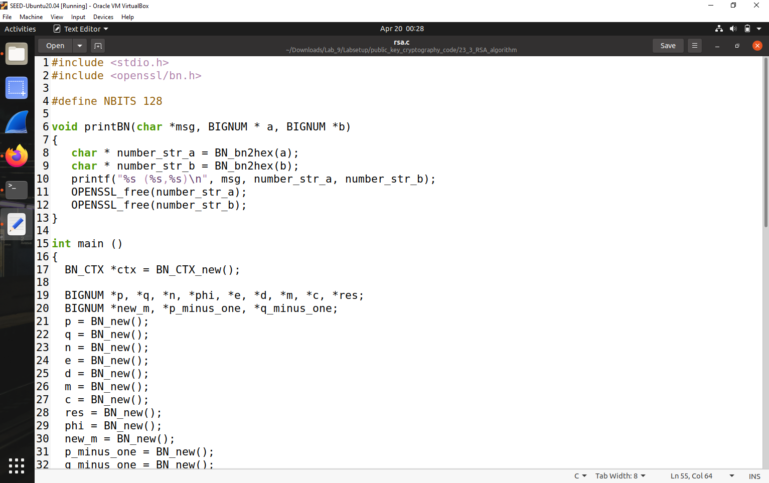

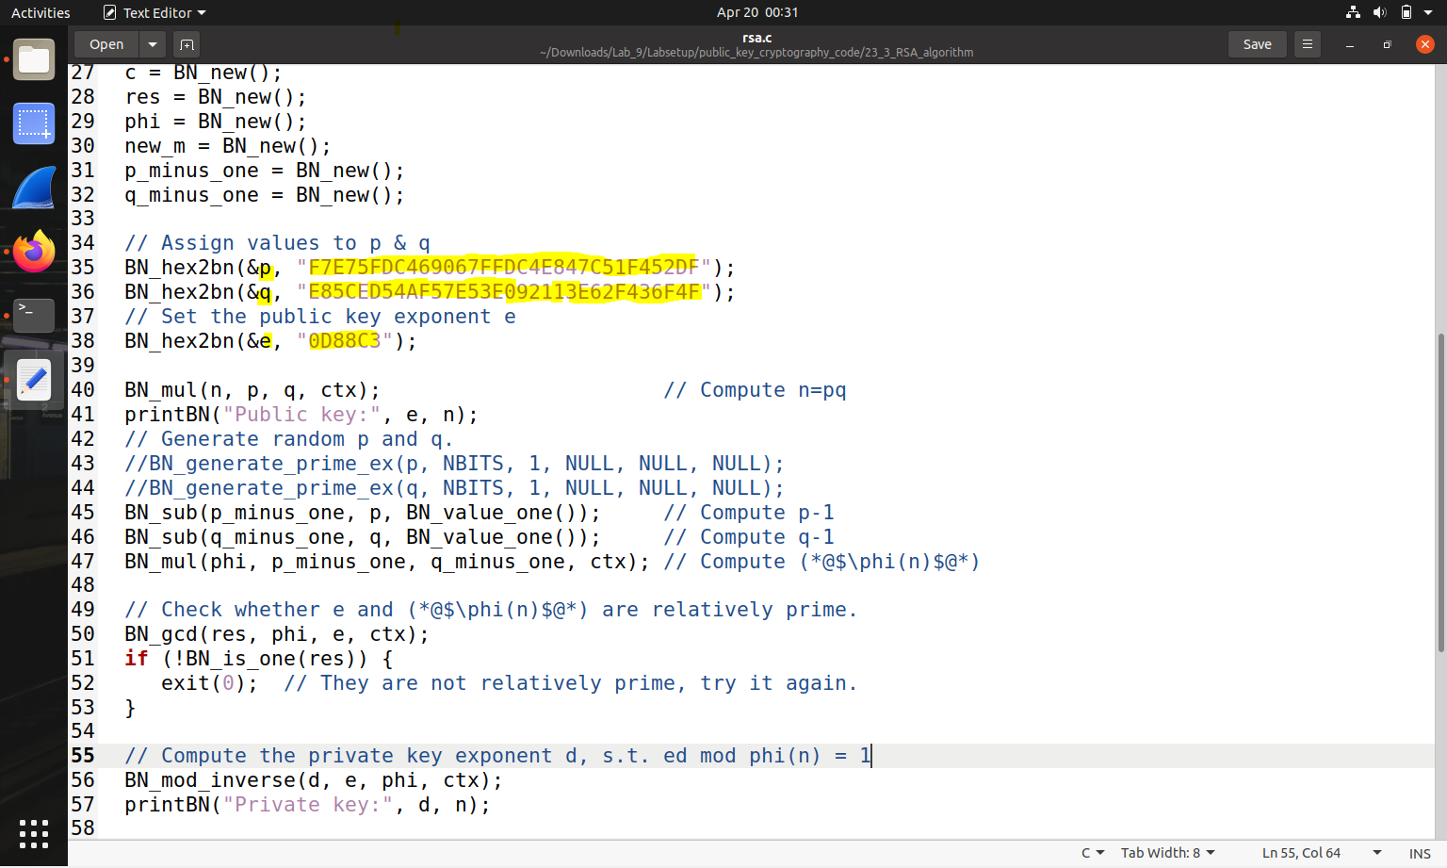



**So the output would be**

**Private Key would be-** 3587A24598E5F2A21DB007D89D18CC50ABA5075BA19A33890FE7C28A9B496AEB

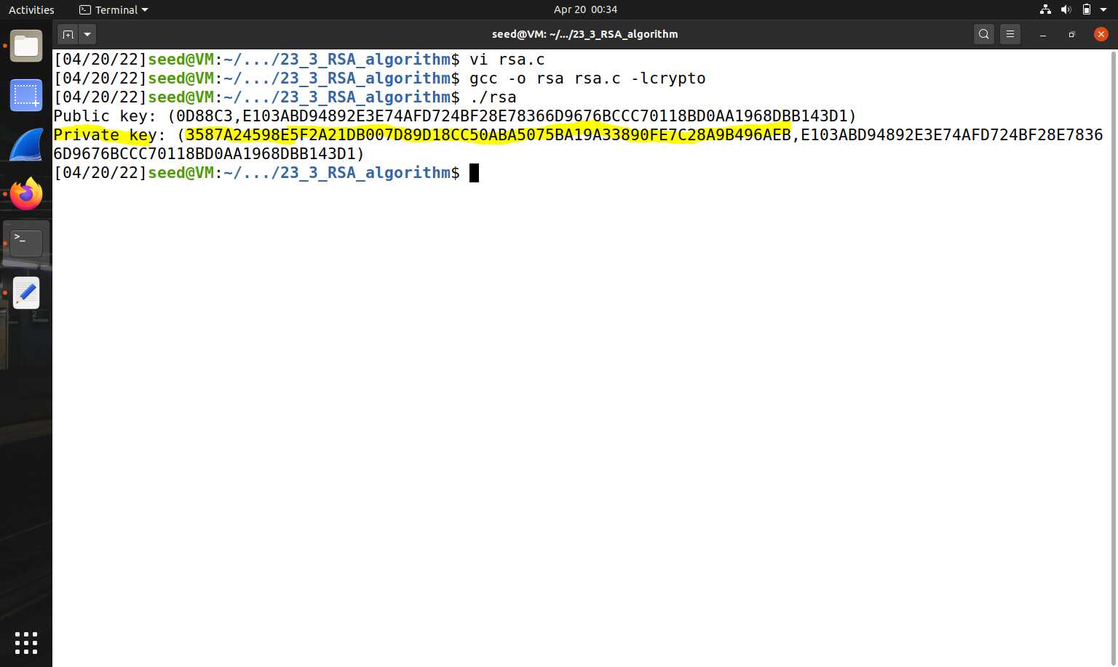



**Task 2: Encrypting a Message**

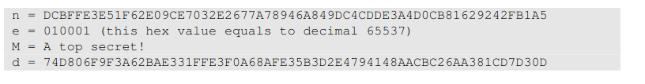

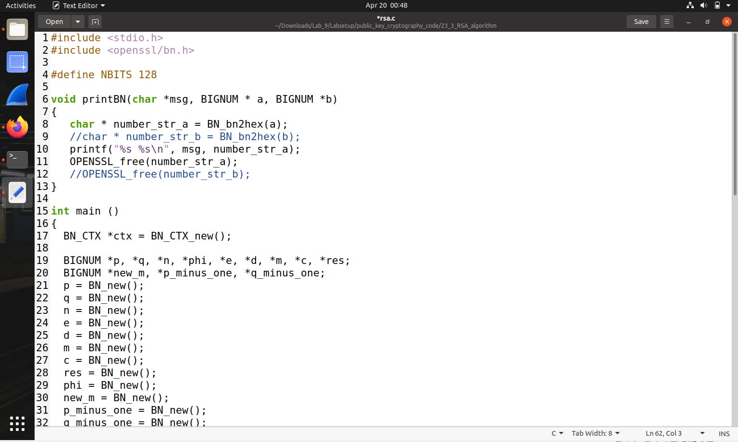

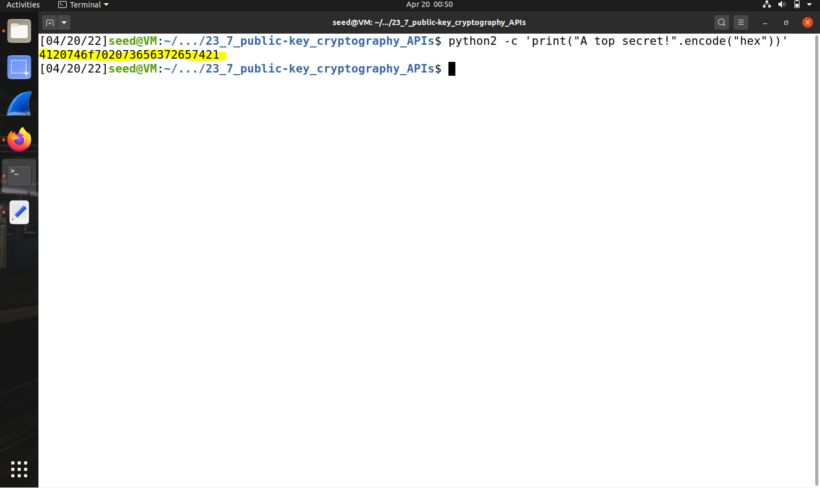



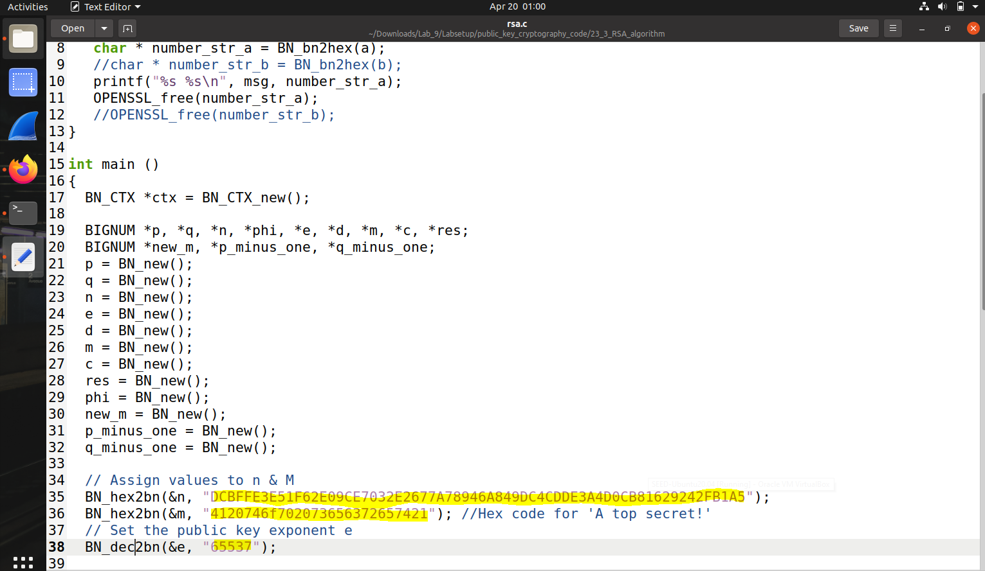

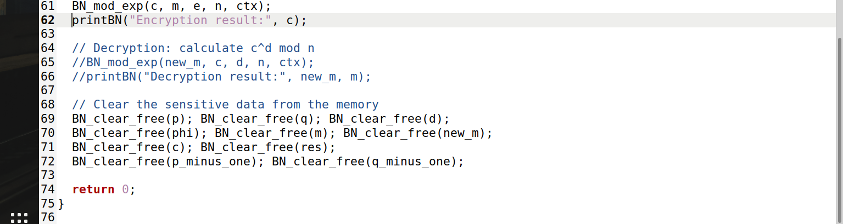

Output--

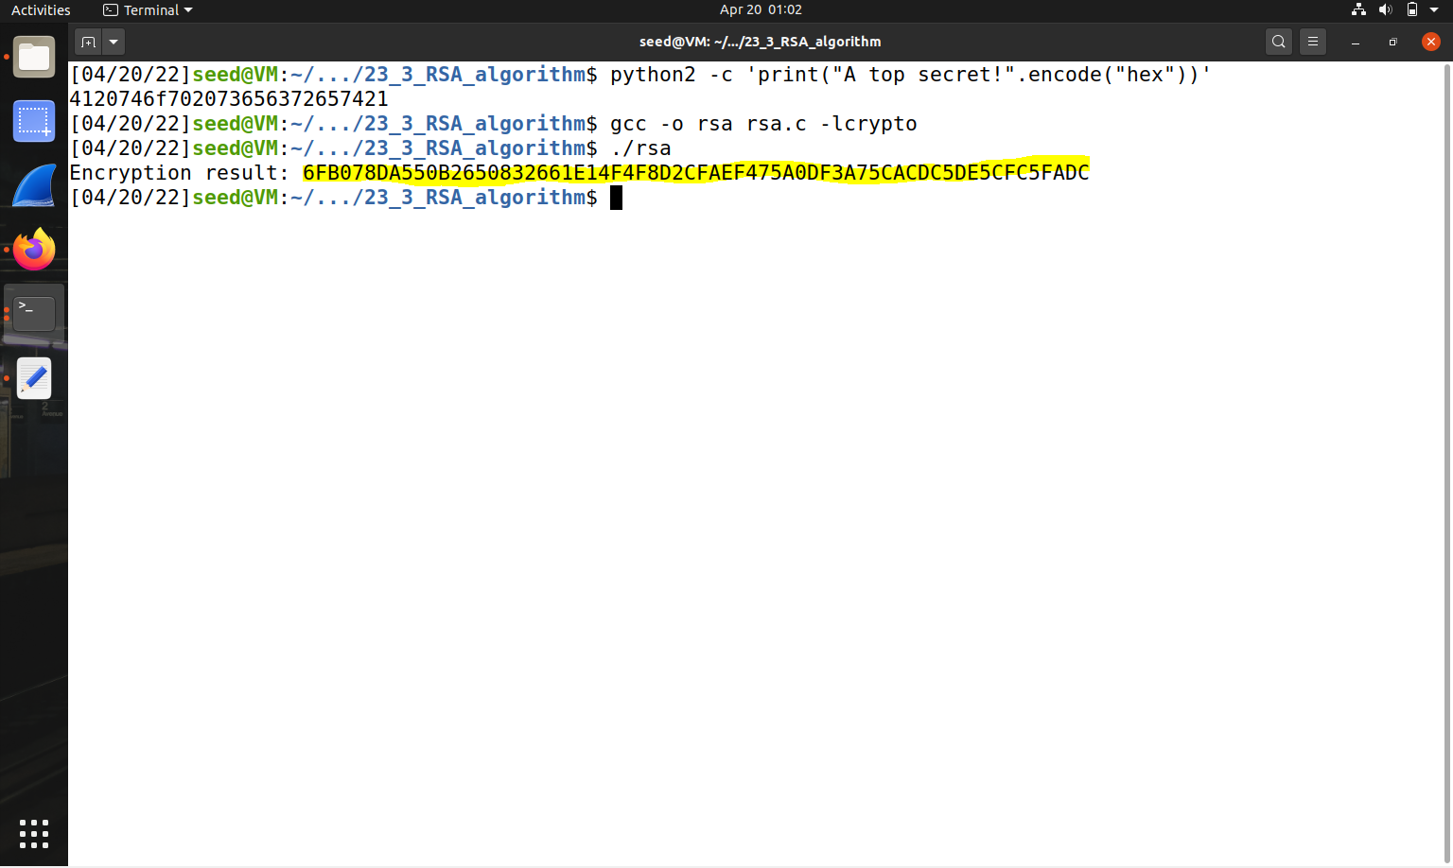



**Task 3: Decrypting a Message**



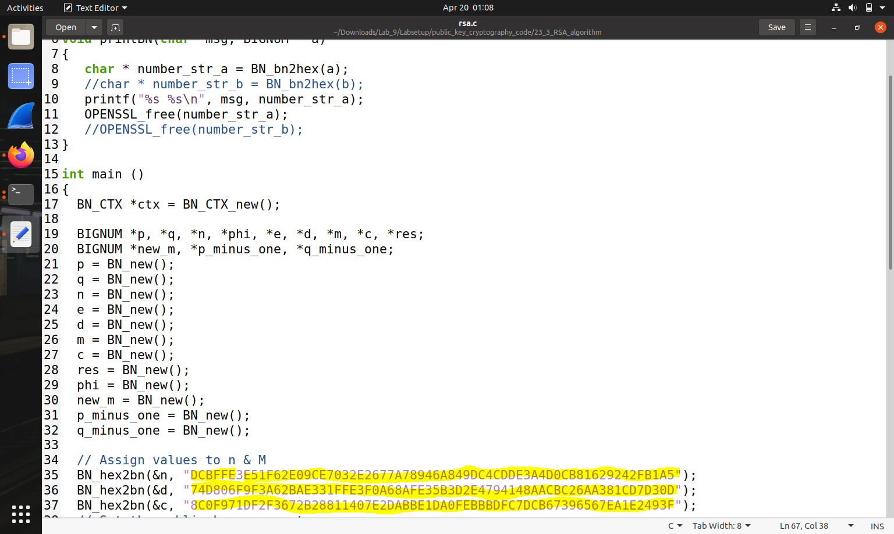



**Execution:**

**Decryption result:** 50617373776F72642069732064656573

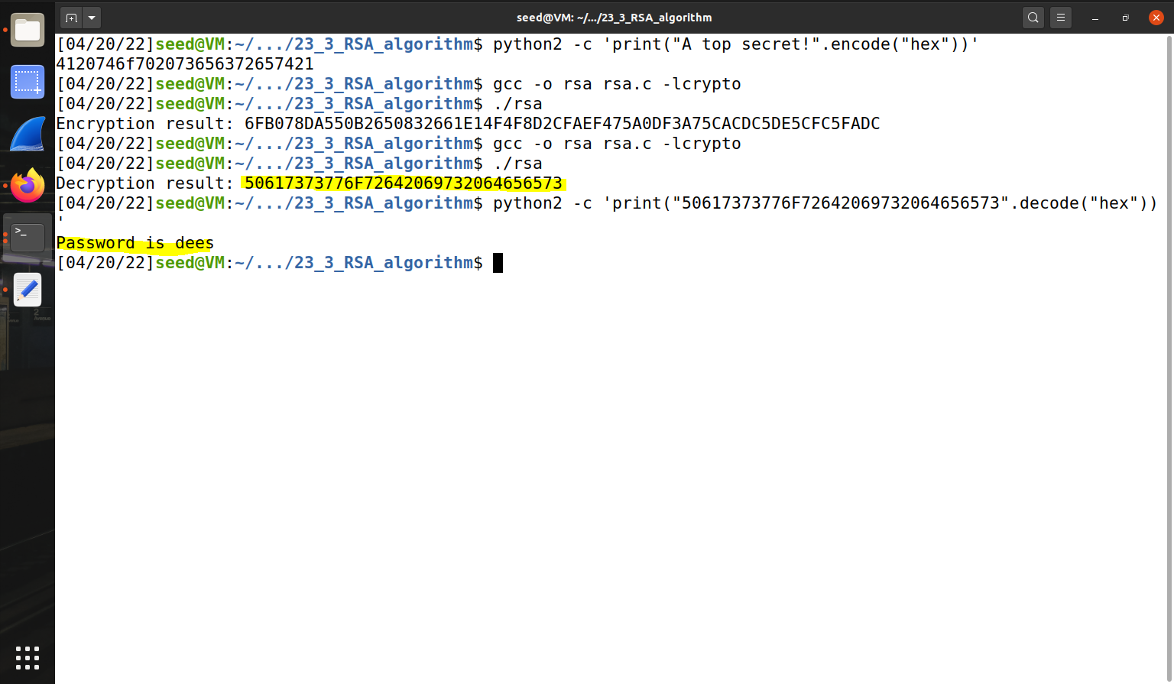



**Task 4**: Signing a Message

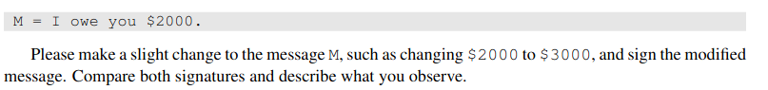

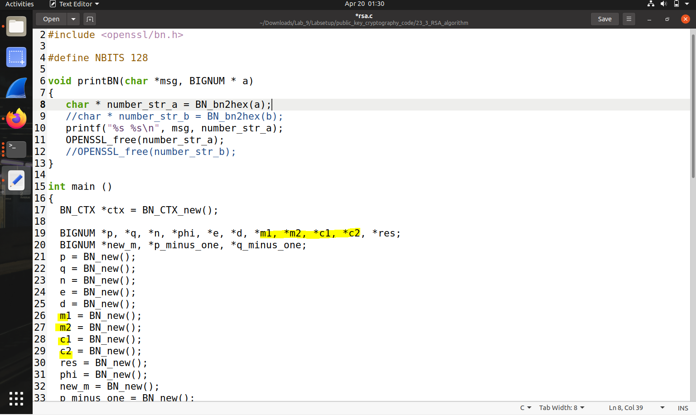



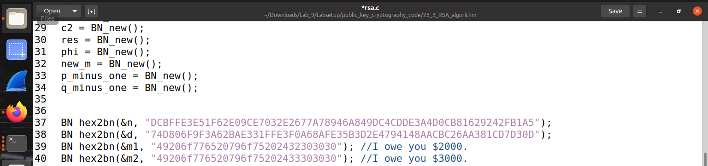

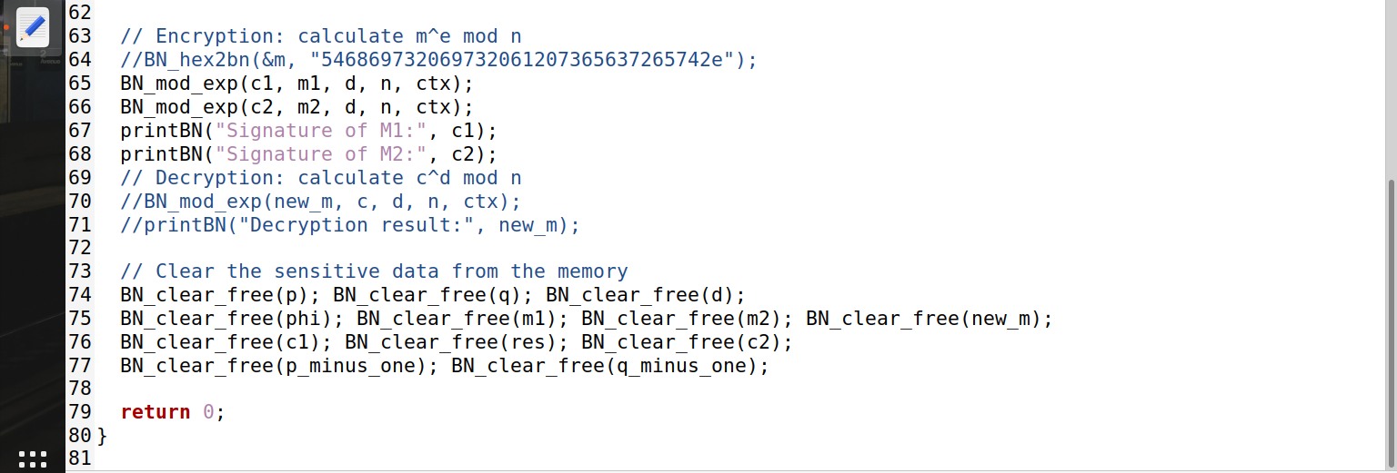

**Execution:**

**Signature of M1**: **80A55421D72345AC199836F60D51DC9594E2BDB4AE20C804823FB71660DE7B82**

**Signature of M2**: **04FC9C53ED7BBE4ED4BE2C24B0BDF7184B96290B4ED4E3959F58E94B1ECEA2EB**

**Task 5-**

Verification of Signature

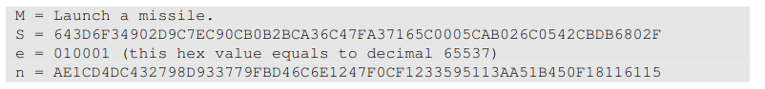

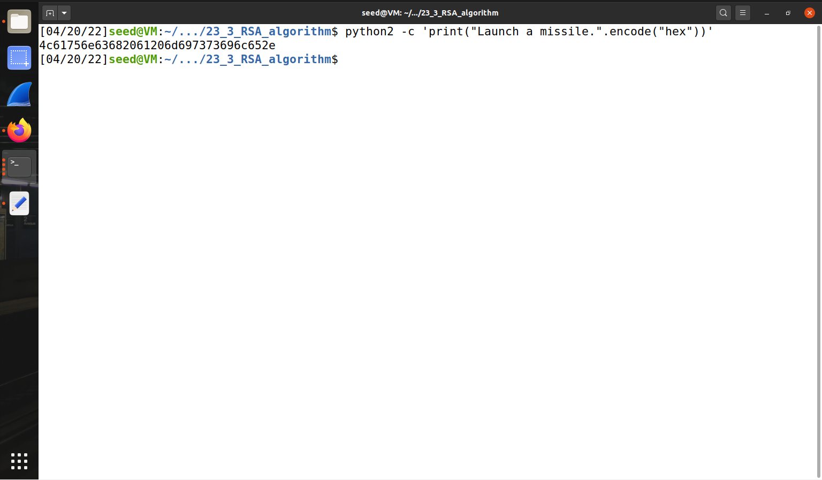

Modification of Code-

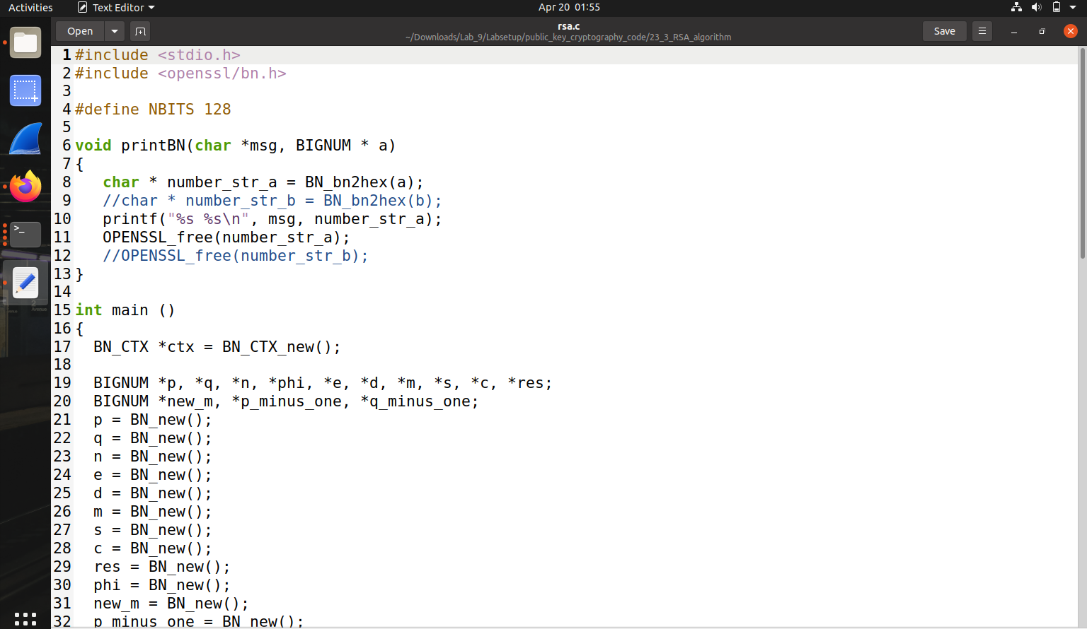

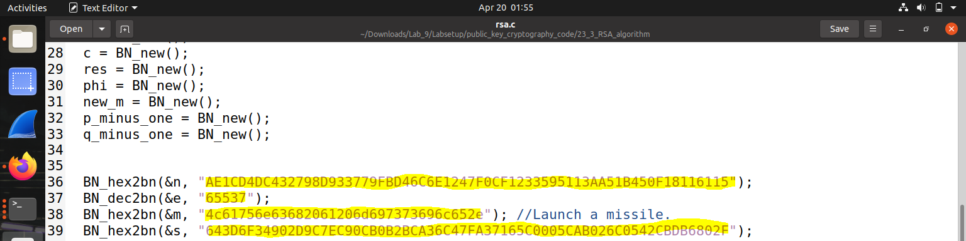



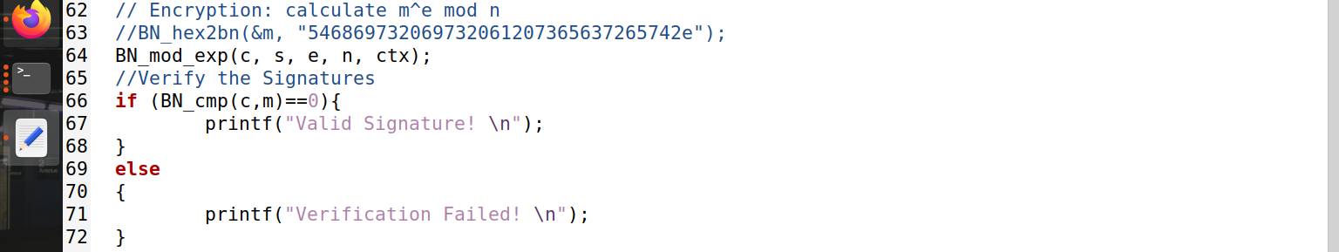

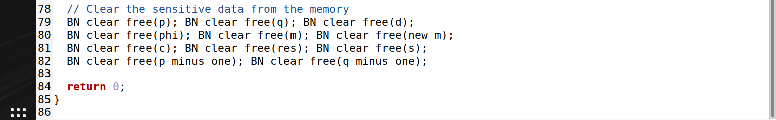

**Execution**

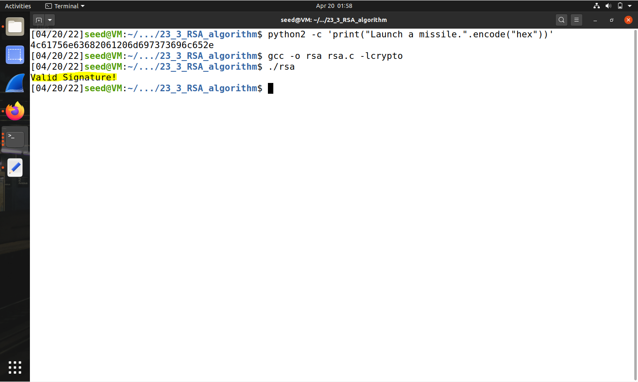



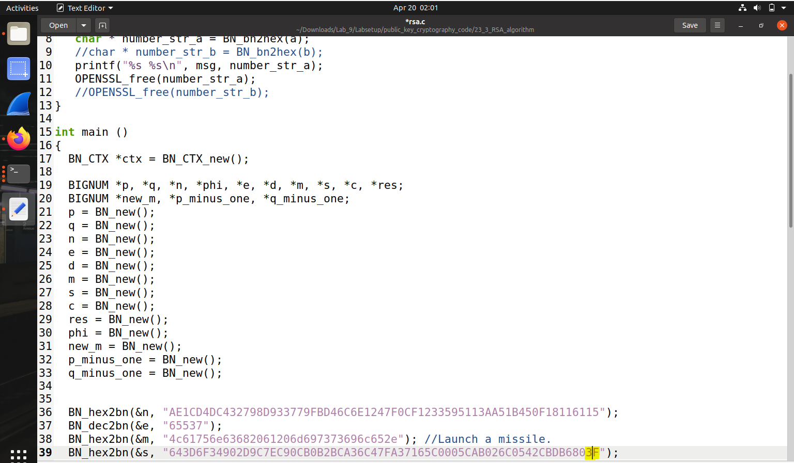



This operation states that the signature will be invalid even if only one byte is changed.

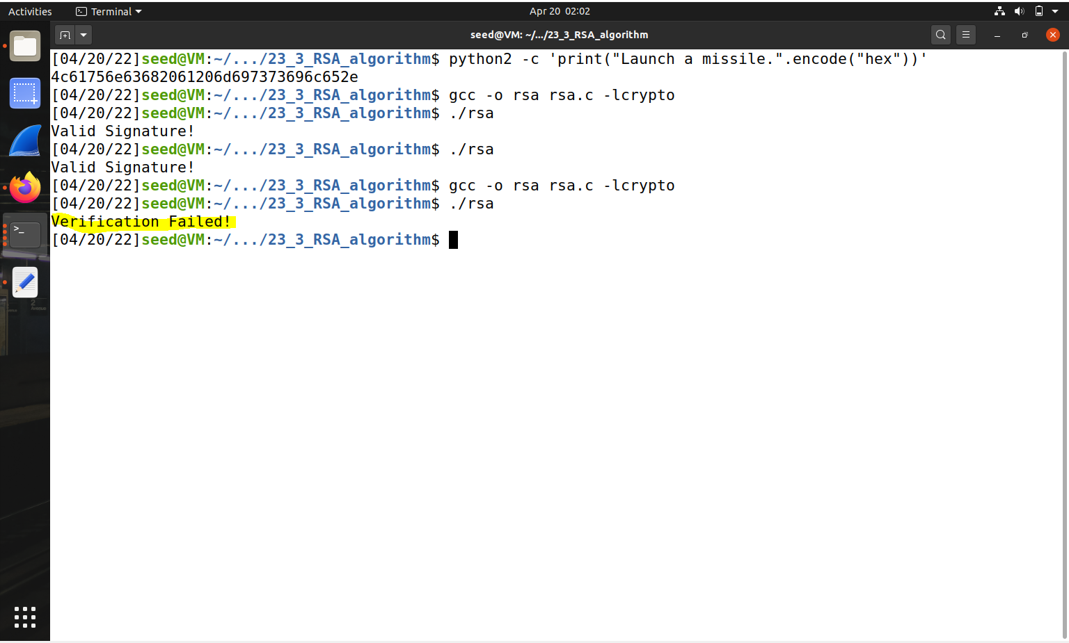



**Task 6**: Manually Verifying an X.509 Certificate

**Step 1:** Download a certificate from a real web server.

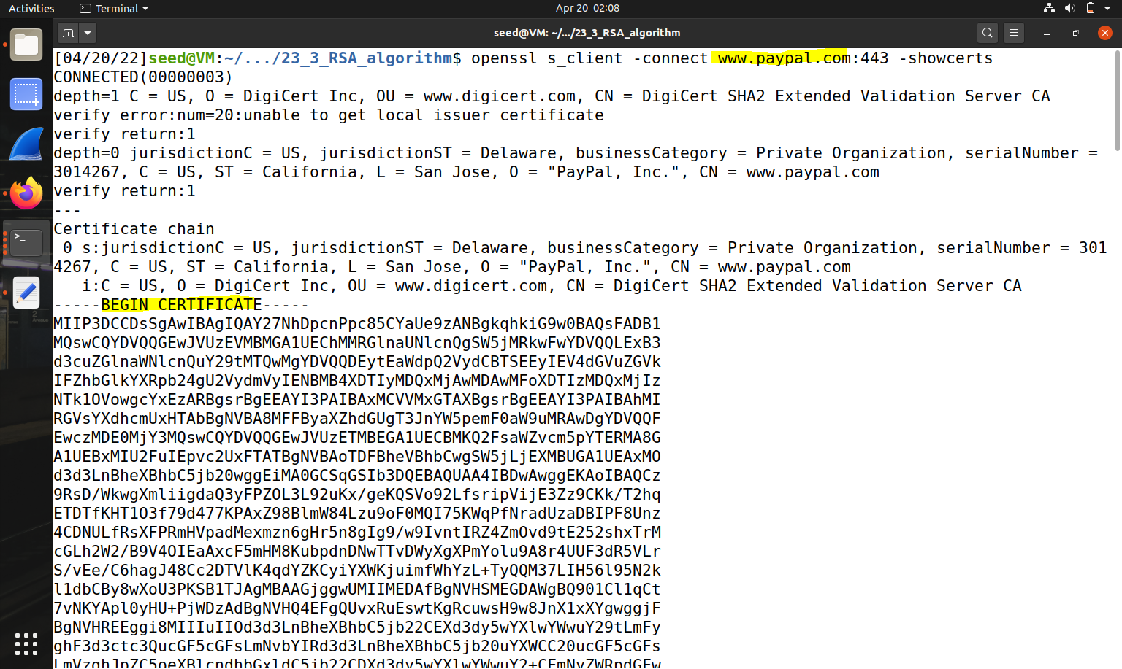



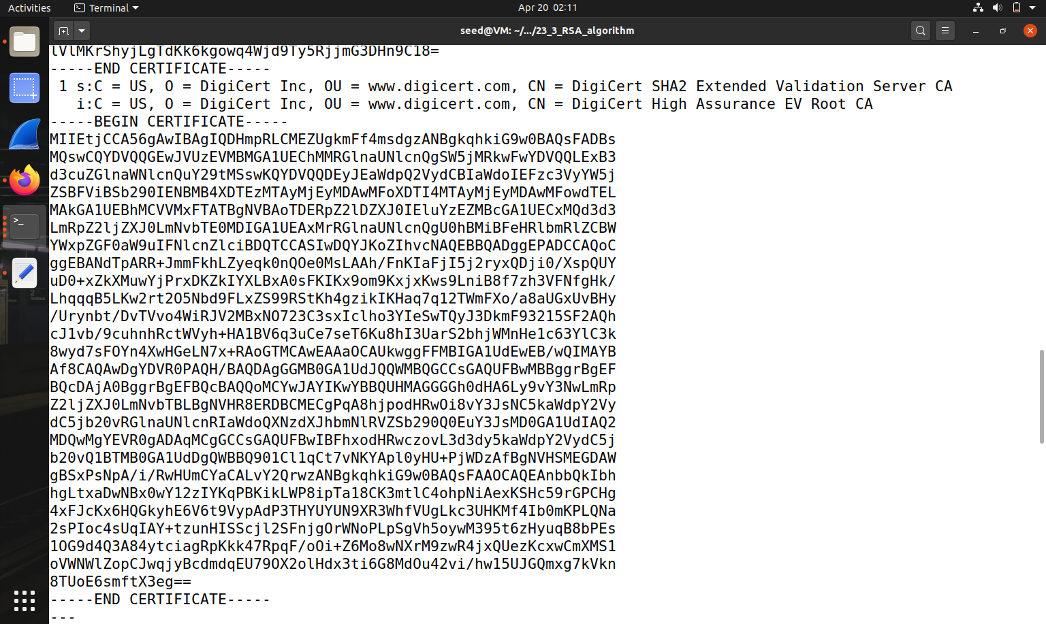

The end result of the command includes certificates. In this task, we can use the CA`s certificates to confirm the server certificates. To down load Certificate, we will Go to Edit – Preferences - Privacy and Security

-View Certificates. Search for the publisher's call and down load its certificates.

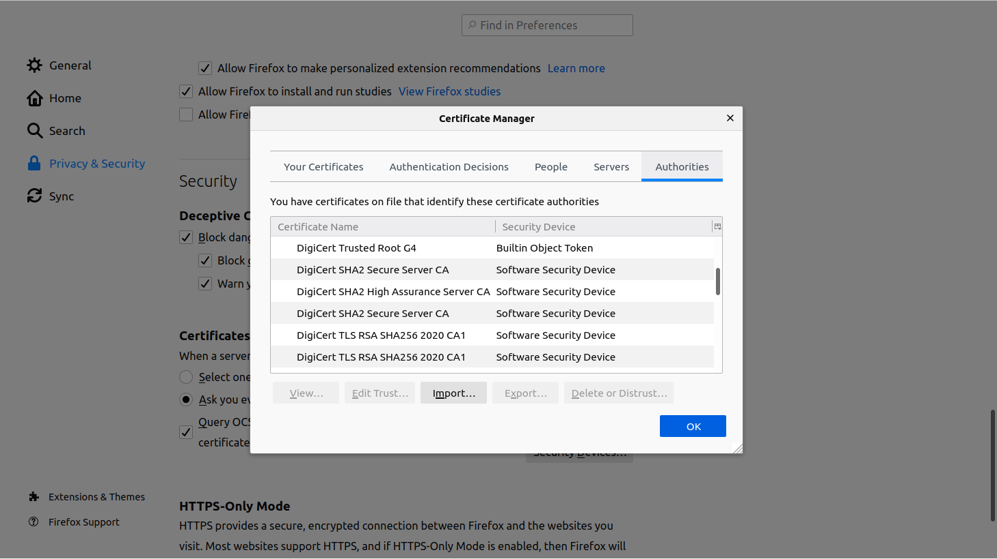

Then copy and paste each certificate (the text between the lines containing "Begin CERTIFICATE" and the line containing "END CERTIFICATE", inclusive) into a file. Let's call the first c0.pem and the second c1.pem .

**Step 2**: Extract the public key(e, n) from the issuer’s certificate.

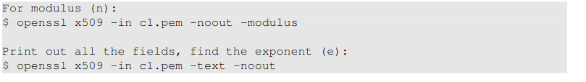

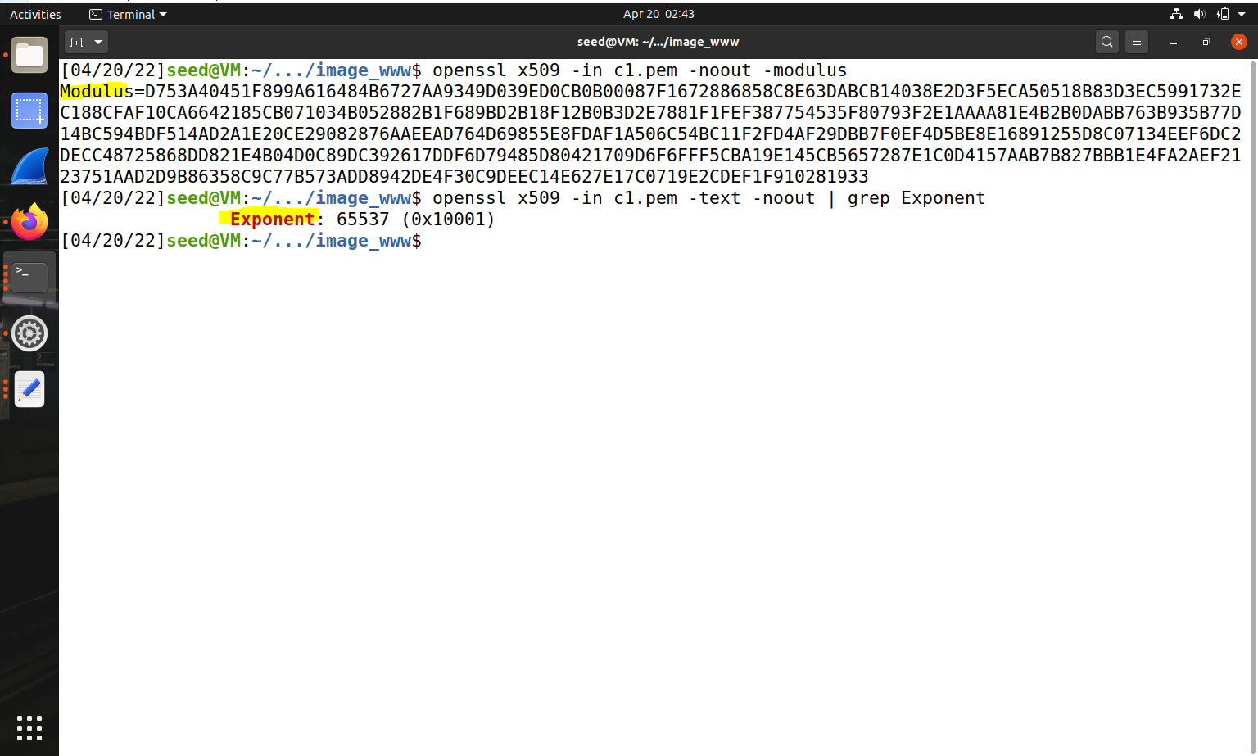



**Step 3**: Extract the signature from the server’s certificate.

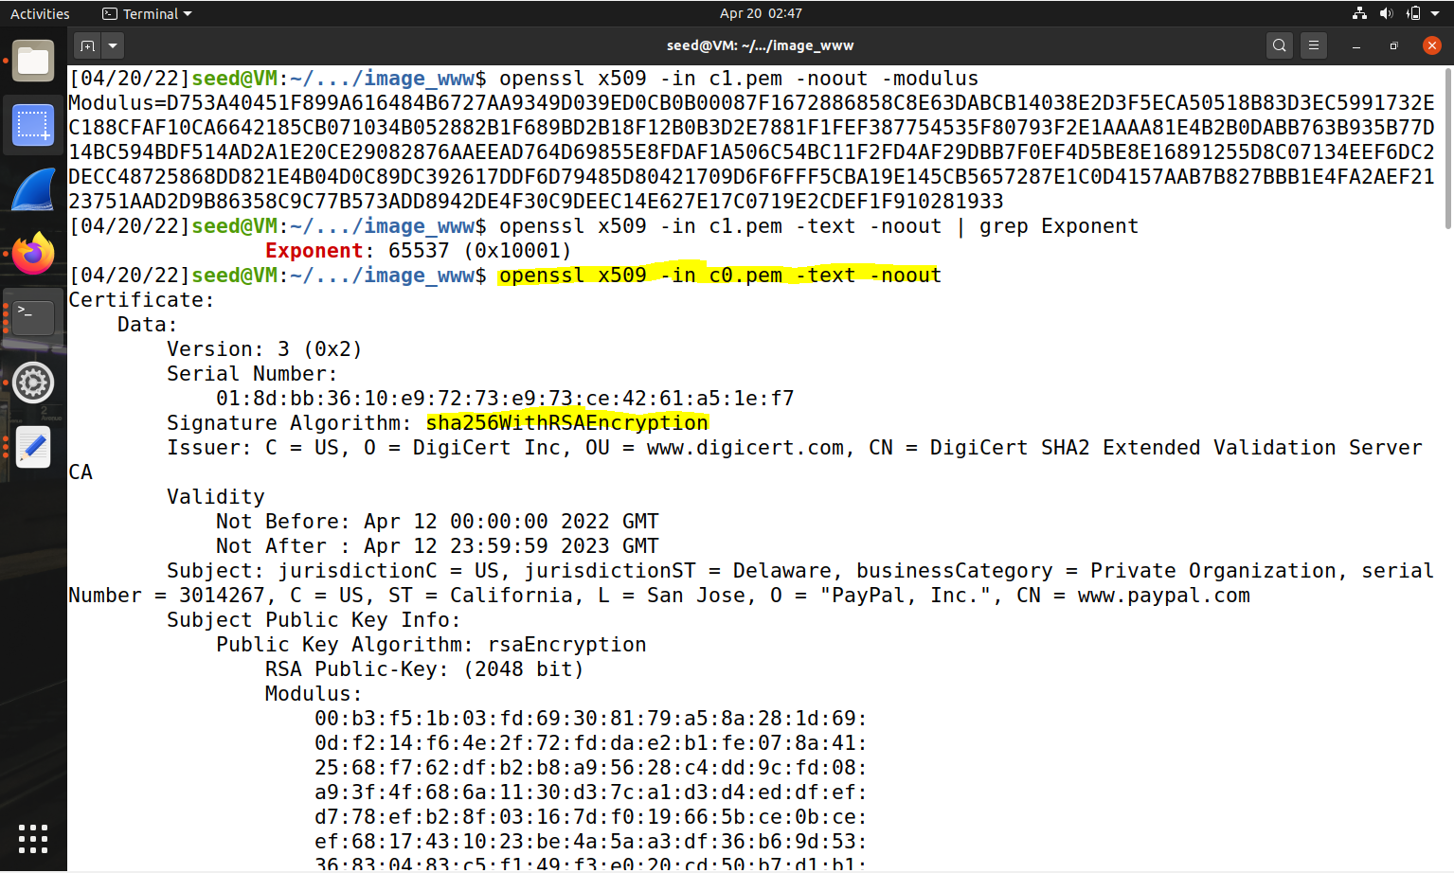



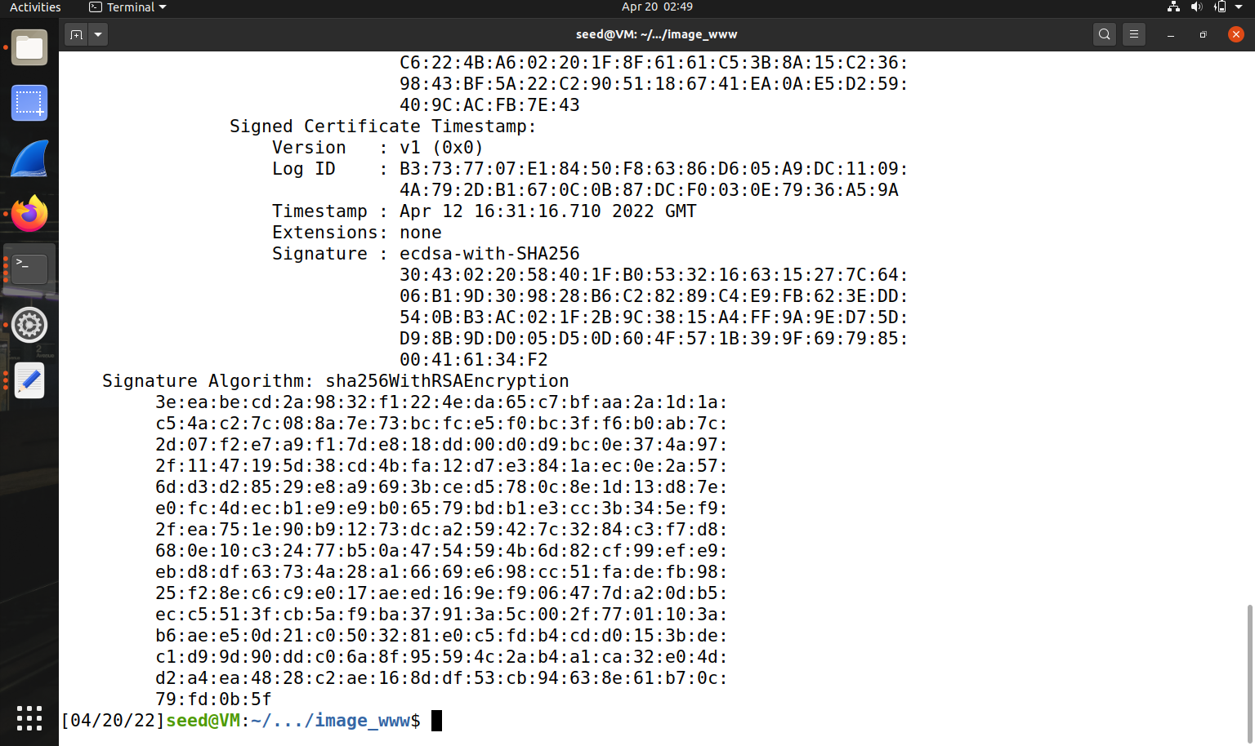

Export the body to "signature", then trim all spaces and colons in it

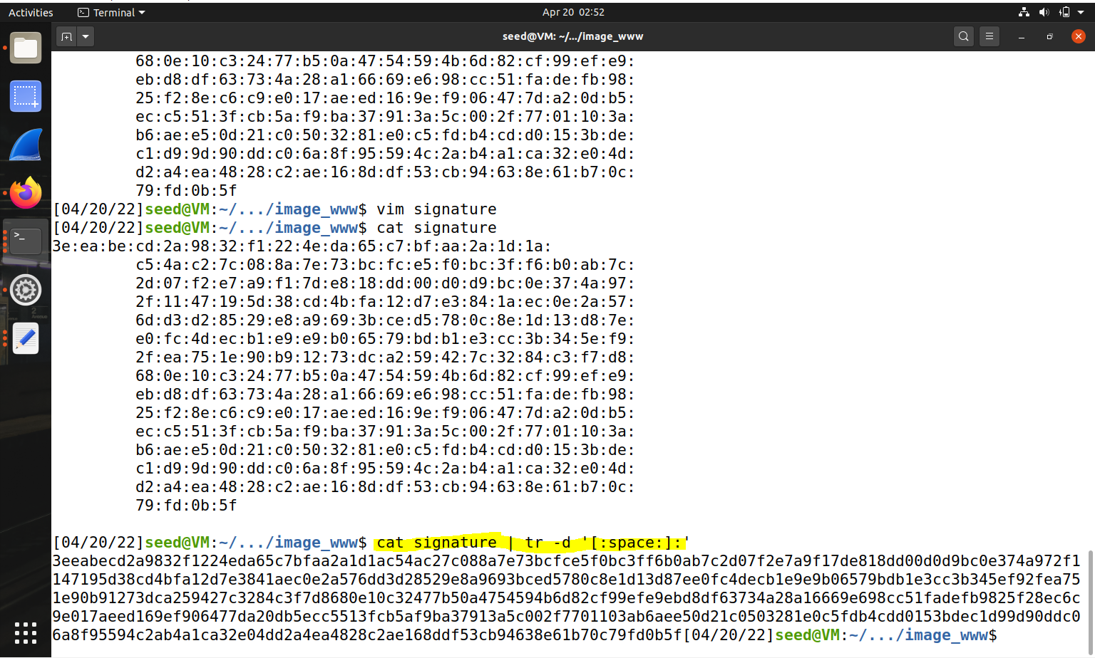



**Step 4:** Extract the body of the server’s certificate.

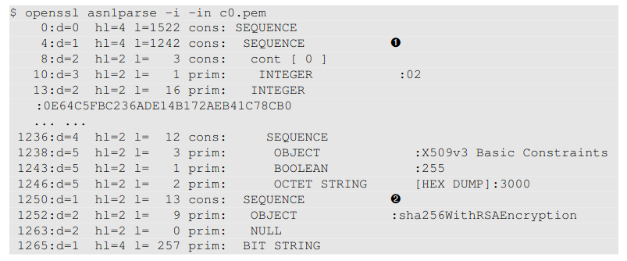 The body part of the certificate is used to generate the hash; second is the signature block. Their offsets are numbers at the beginning of the line. The initial offset for an X.509 certificate is always the same (i.e., 4), but the end of a certificate depends on the length of the content. I used the -strparse option to get the fields from offset 4, which will give us the body of the certificate, excluding the signature block.

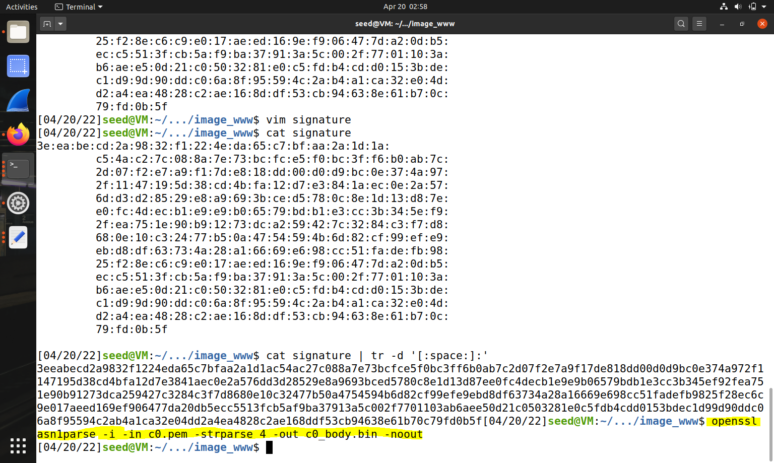



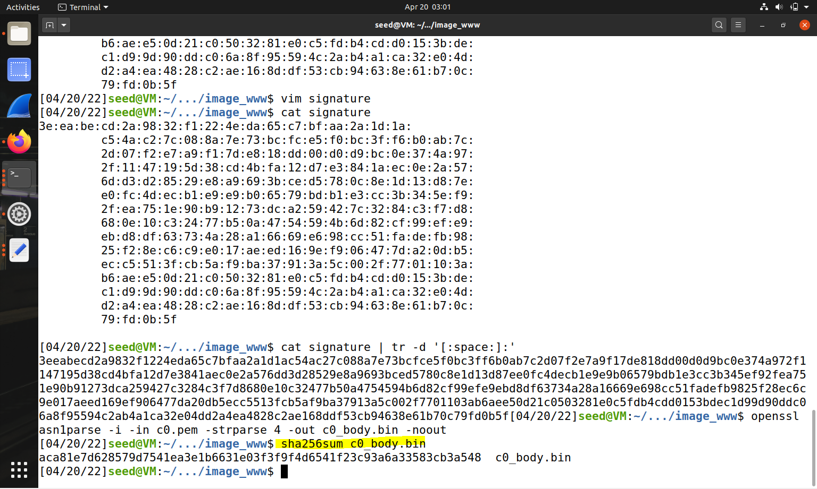



Parsing Server Certificate-

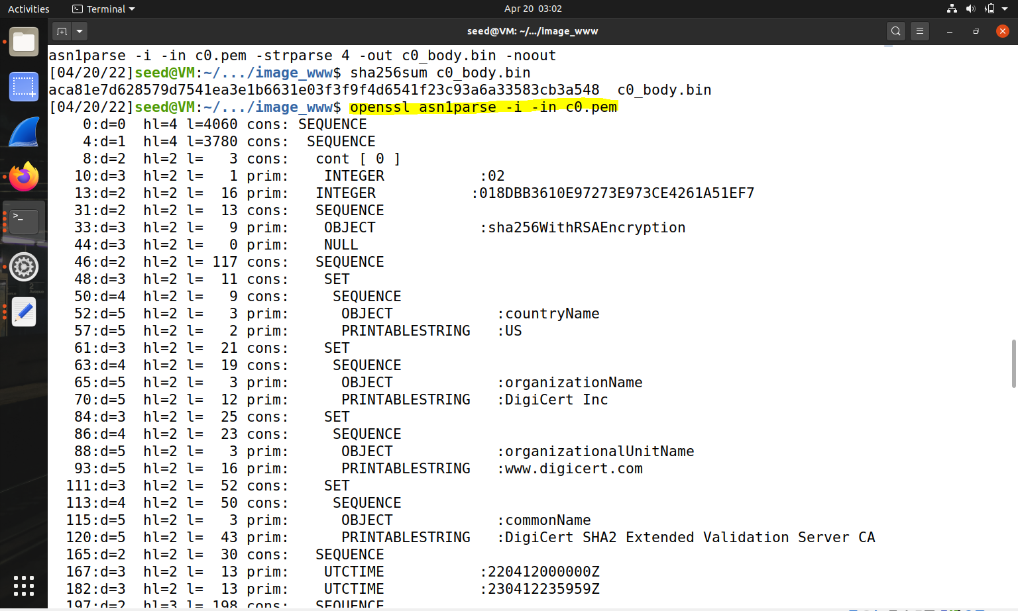



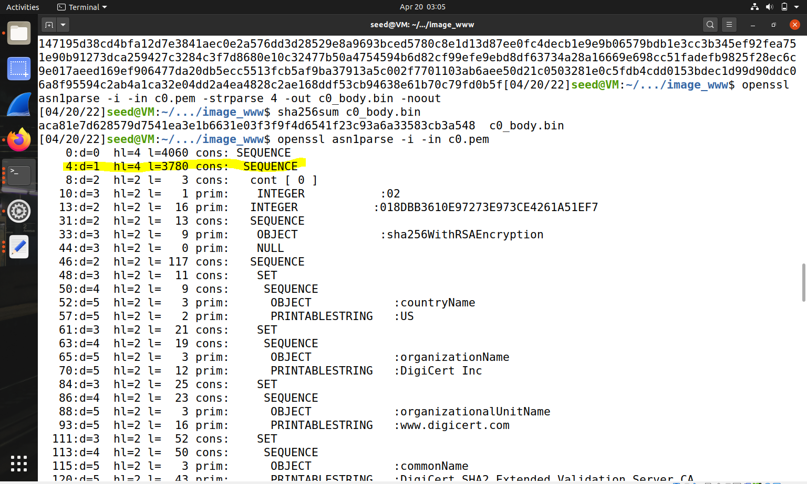



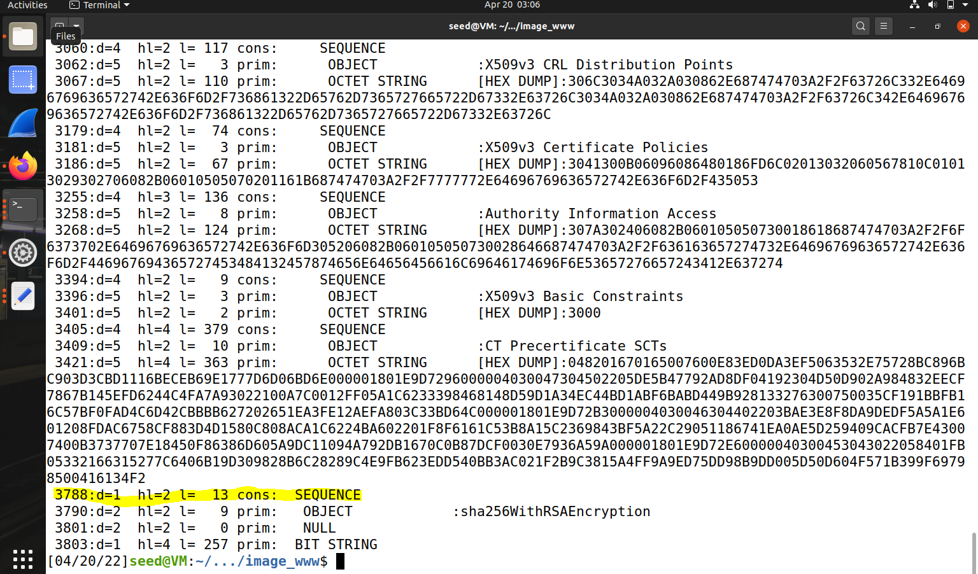



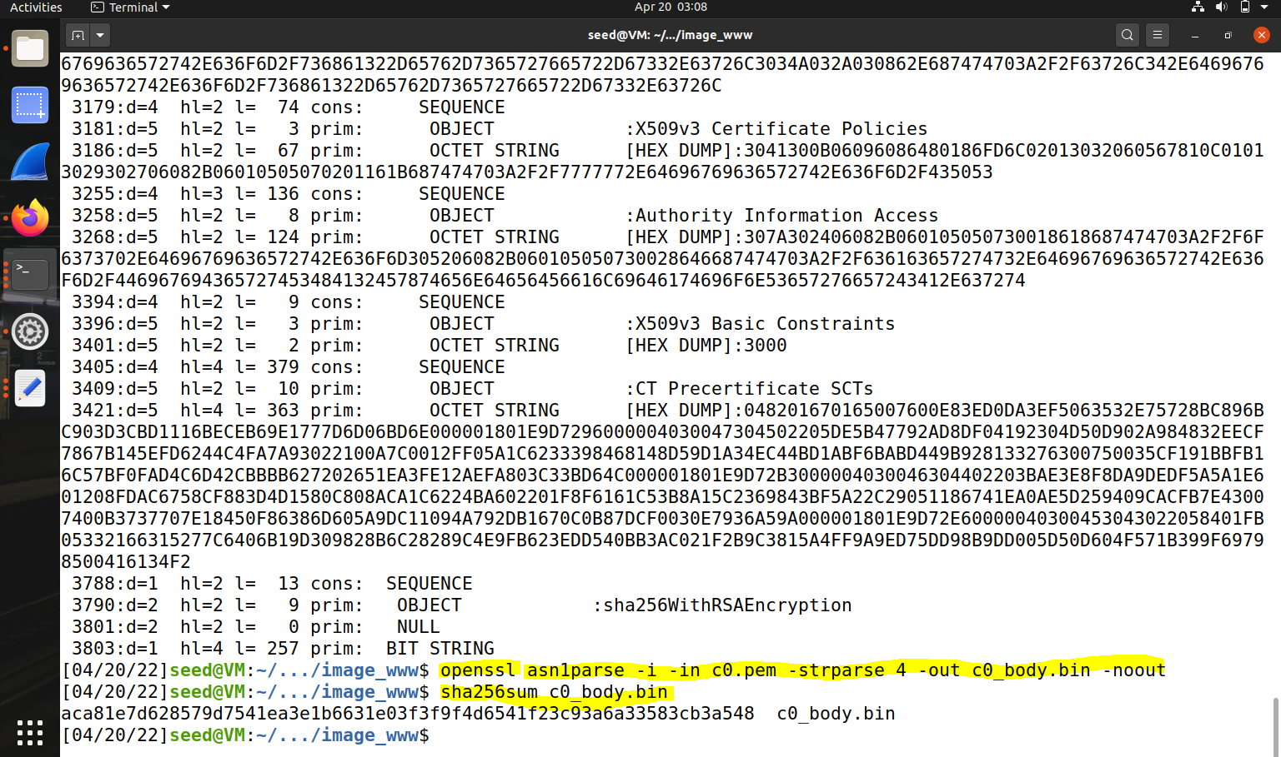



**Step 5: Verify the signature.**

